DEPARTMENT OF INFORMATION TECHNOLOGY

COURSE CODE: DJ19ITL503 DATE: 14-09-24

COURSE NAME: Data Warehousing and Mining CLASS: T Y B. TECH

NAME: Anish Sharma SAP: 60003220045

# LAB EXPERIMENT NO. 4

AIM: Perform OLAP operations on a given dataset using Pivot Table in Excel.

Describe OLAP and its operations in detail. (Refer following example)

OLAP (Online Analytical Processing) is a robust technology that empowers users to analyze data interactively across multiple dimensions, playing a crucial role in business intelligence by supporting decision-making processes. By enabling quick retrieval, aggregation, and visualization of large datasets stored in data warehouses, OLAP allows users to examine data from various perspectives, such as time, location, and product categories. Dimensions in OLAP refer to the entities or perspectives by which data can be analyzed, while measures are the numerical data points, like sales or profit, that can be aggregated and analyzed against these dimensions.

The core OLAP operations—Slice, Dice, Roll Up, Drill Down, and Pivot—offer powerful ways to explore and analyze data. The Slice operation selects a specific layer from the OLAP cube, such as focusing on data for a particular time period like Q1. Dice narrows down the data further by selecting specific values across multiple dimensions, creating a sub-cube. Roll Up aggregates data to a higher level, like summarizing city-level data to the country level, while Drill Down does the opposite by providing more granular details, such as breaking down quarterly data into monthly figures. Pivot, or rotation, changes the orientation of the data, allowing users to view it from different perspectives, enhancing analytical insights.

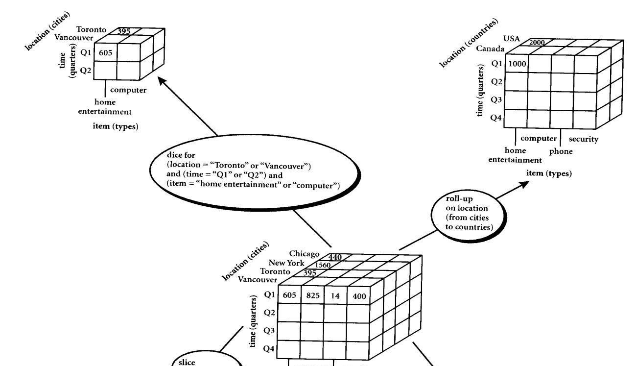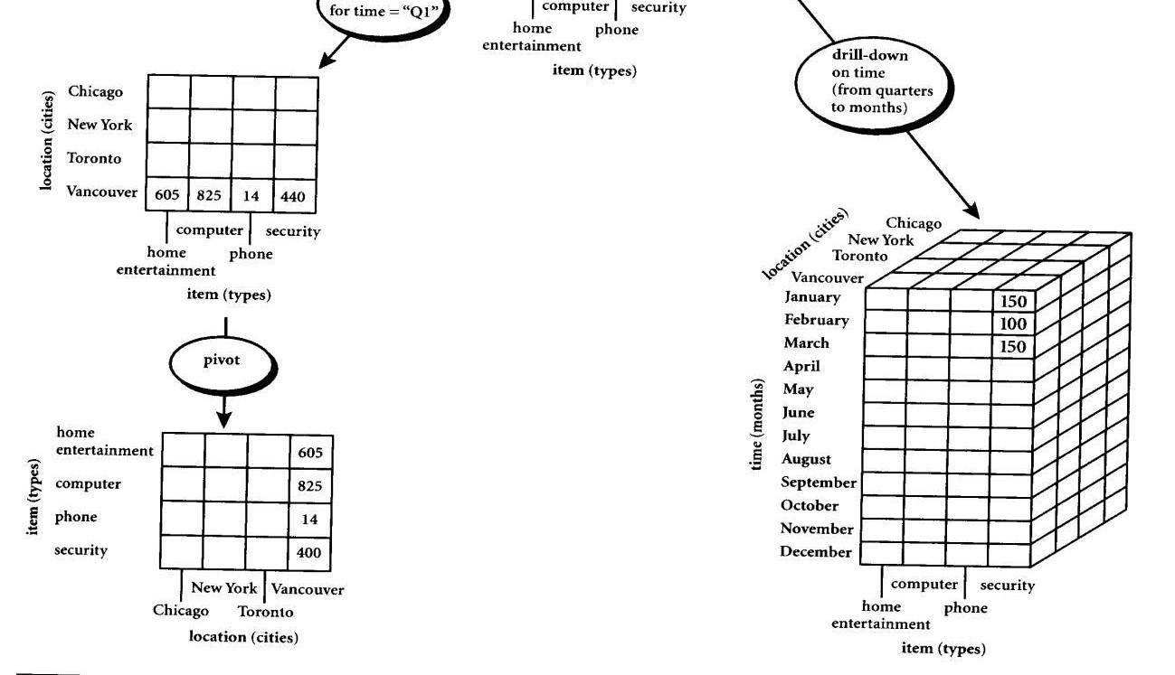

Figure 1: EXAMPLE

EXERCISE 1

Consider a datawarehouse for a hospital, where there are three dimensions:

1. Doctor
2. Patient
3. Time

With two measures

* 1. Count
  2. Charge

Where Charge is the fee that the Doctor charges a patient for a visit.

Using the above example describe the following operations:

* 1. Slice
  2. Dice
  3. Roll Up
  4. Drill Down
  5. Pivot

NOTE: Assume data according to the dimensions and measures and explore individual tasks diagrammatically.





EXERCISE 2

Steps to be performed:

1. Create a PivotTable

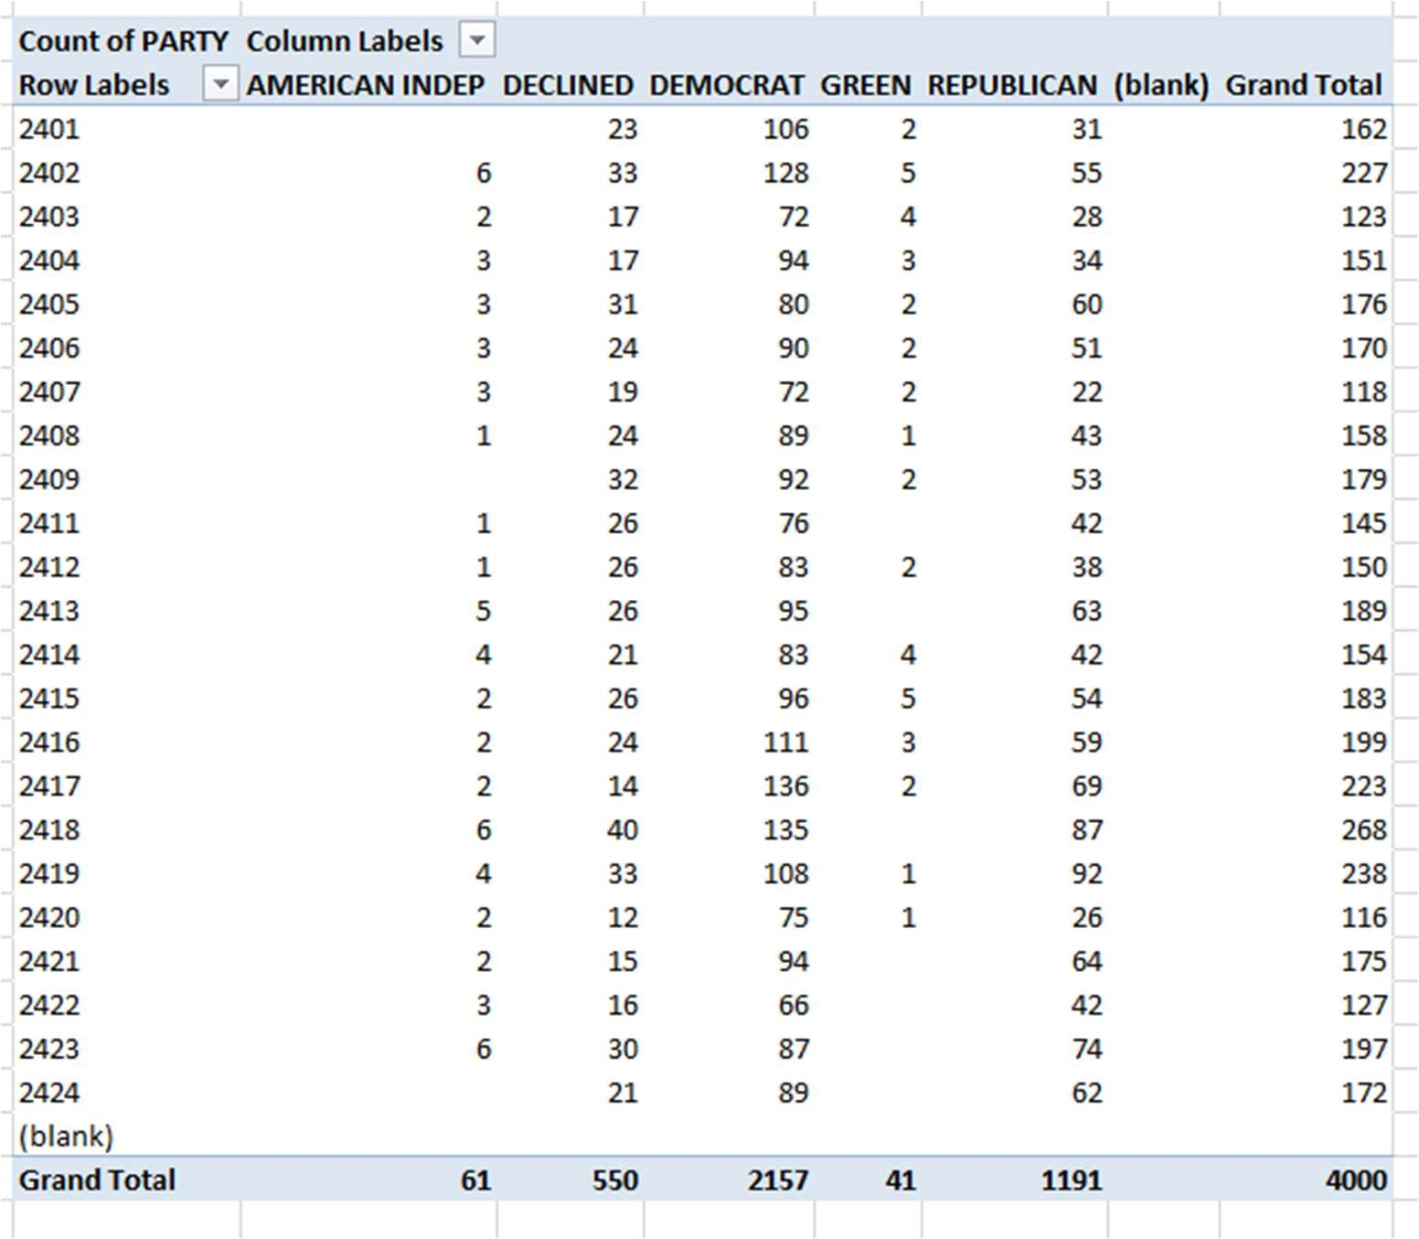

1. Pivoting data

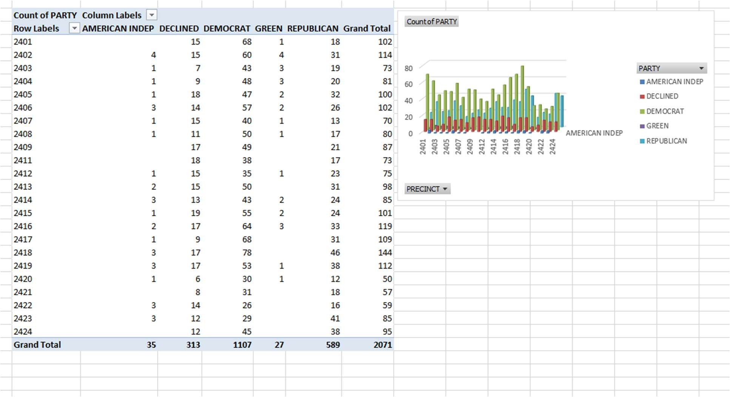

1. Add Filters

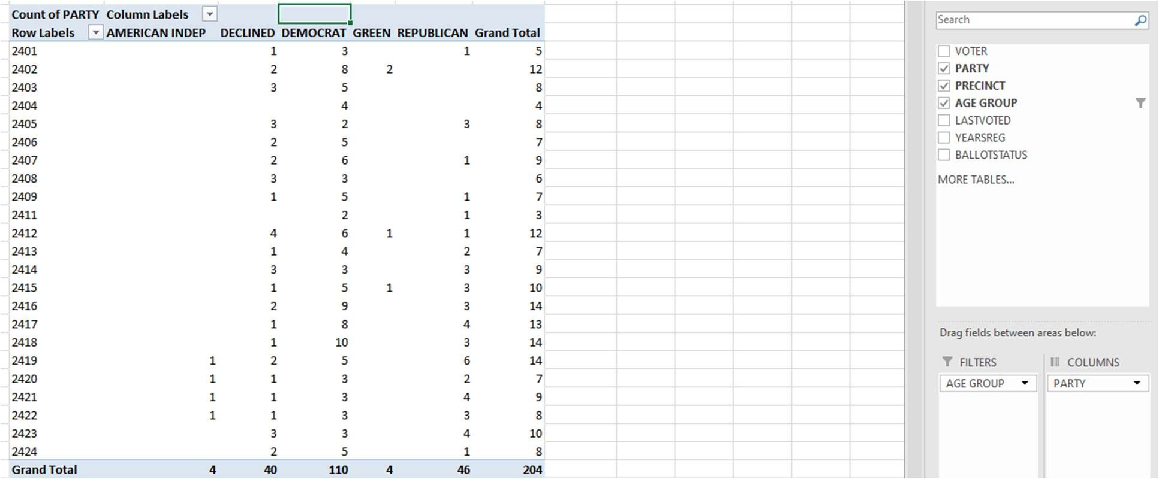

1. Add a slicer

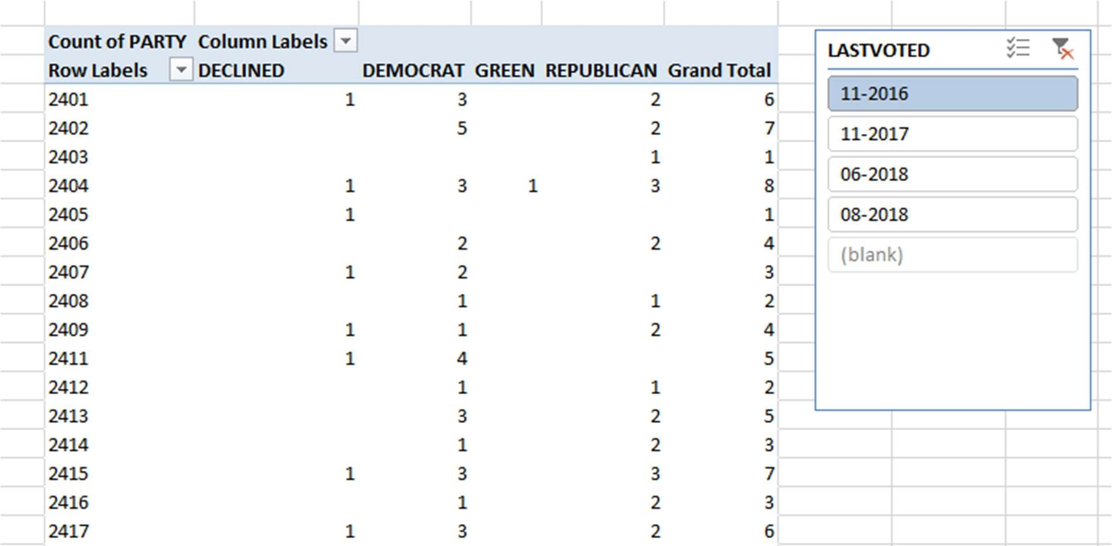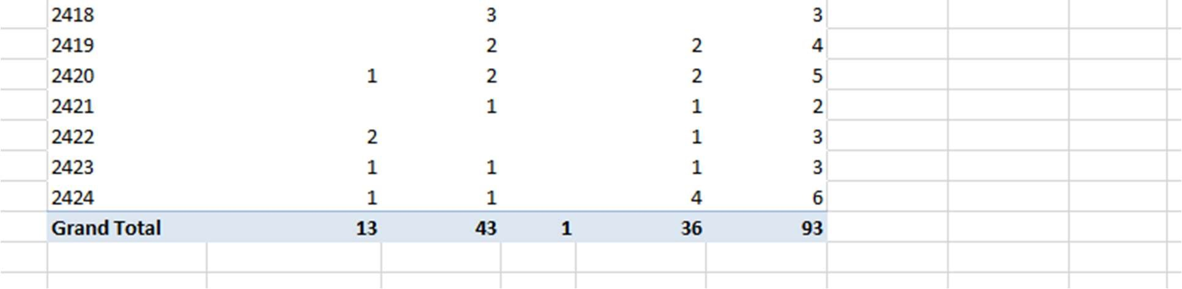

References:

[1] https://www.timeatlas.com/excel-pivot-tables/#h-how-to-create-excel-pivot-table